H.T No
Regulations:
A19

Sreenidhi Institute of Science and Technology
(An Autonomous Institution)
Code No:7X211 Date: 03-Oct-2020 (FN)

M.Tech I-Year II-Semester External Examination, October - 2020 (Regular)
POWER SYSTEM STABILITY (EPE)

Time: 2 Hours Max.Marks:70

Note: a) No additional answer sheets will be provided.
b) All sub-parts of a question must be answered at one place only, otherwise it will not be valued.
c) Missing data can be assumed suitably.

ANSWER ANY FIVE QUESTIONS. EACH QUESTION CARRIES 14 MARKS.

1. | a) | Explain various types of Voltage stability. Deduce the expressions for reactive power at sending and receiving end of a simple system and explain the variation of reactive power demand with respect to load. | [7M]
 | b) | Illustrate at least two voltage collapse incidences with necessary background. | [7M]
2. | a) | Explain the concept and usage of voltage collapse proximity indicator. | [7M]
 | b) | Explain how voltage stability is evaluated using Jacobian elements. | [7M]
3. | a) | Define voltage security and explain any two methods of improving voltage stability mentioning advantages and disadvantages. | [7M]
 | b) | Illustrate the methods of assessing voltage stability margin of compensated systems. | [7M]
4. | a) | Explain the modelling of induction machine for steady state and transient stability studies with the help of equivalent circuit. | [7M]
 | b) | During voltage decay or voltage swing, voltage at a bulk power delivery high voltage bus drops from 1.05 pu to 0.9 pu. With no regulation, calculate the voltage at the utilization point assuming a reactance of 15% on the load base. (the reactance comprises of 10% bulk power delivery transformer reactance, 3% distribution transformer reactance, and 2% feeder reactance.) the voltage at the load, V is initially 1.0 pu. The 1.0 pu load is a motor with Pv=0 and Qv=2. Capacitive compensation is used to achieve 1.o pu voltage. Calculate the voltage at the load when the source voltage, E, drops to 0.9 pu.  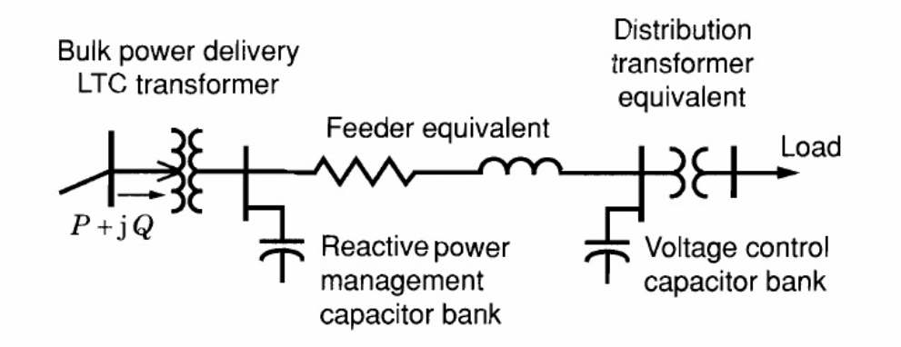 | [7M]
5. | a) | Explain the significance of swing equation, and deduce the solution of the nonlinear swing equation. | [7M]
 | b) | Illustrate how a multi machine system can be modelled using phase plane analysis. | [7M]
6. | a) | What are various discrete supplementary controls used and explain any one control in detail. | [7M]
 | b) | Explain how the discrete control of excitation systems is implemented. | [7M]
7. | a) | Explain the relationship between synchronous stability and voltage stability. | [7M]
 | b) | How does a PV curve help in assessing voltage stability of a system? | [7M]
8. | a) | How can voltage stability margin be expressed? Explain. | [7M]
 | b) | List out and explain ways different to improve voltage stability. | [7M]

-- 00 -- 00 –

